Other Server-Side Web Scripting Technologies

1. Active Server Pages (ASP)

* development structure or framework for creating web sites
* developed in the mid 90’s, version 1.0

History

* Version 1.0 – Developed in December 1996 by Microsoft
* Combination of programming languages: Perl and C++
* ASP.NET - Modernized programming environment with an easy linkable and code optimization
* IIS 4.0 – Newer version of ASP.NET, Developed in 1997
* XPS – Original developers were Mark Anders and Scott Guthrie

Definition of Terms

1. Perl – It is a high-level general-purpose programming language that is being utilized especially for enhancing web applications.
2. C++ - General-purpose object-oriented programming language which was developed by Bjarne Stroustrup and also an extended version of the C language.
3. VBScript
4. C Sharp (C#)
5. PHP

Concept and Sample Codes

1. Framework
2. Classic ASP

* Developed in the year 1998 as the first Microsoft’s server-side we scripting language
* File extension: .asp and is written in VBScipt

1. ASP.NET

* Released in the year 2002 as a success to Classic ASP
* File extension: .aspx and is written in C Sharp (C#)
* Latest official version: ASP.NET 4.6
* Important redesign of ASP.NET: ASP.NET 5

1. ASP.NET Web Forms

* It is an event driven application model and is not part of the new ASP.NET Core

1. ASP.NET MVC

* Model-View-Controller (MVC) Application model
* Was merged into the new ASP.NET Core

1. ASP.NET Web Pages

* Single Page Application (SPA) Application Model
* The same with PHP and Classic ASP

1. ASP.NET API

* Application Programming Interface (API) Application Model
* Merged into the new ASP.NET Core

1. ASP.NET Core

* Released in the year 2016
* Merged with ASP.NET MVC, ASP.NET Web API, and ASP.NET Web Pages to be created as a one application framework

1. Libraries
2. System.Web – Permits internet browser or server communication

* Supplies classes for administering HTTP outcome to the user (HTTP Response) and reading HTTP Requests

1. System.Web.UI – Making web form pages that includes the page class and other definite classes utilized to make web user interfaces
2. System.Web.UI.HtmlControls – Used for-specific controls that can be combined with web forms to make web user interfaces
3. System.Web.UI.WebControls – Making ASP.NET web server controls
4. System.Web.UI.WebControls.WebParts – An integrated set of classes and interfaces for making web pages whose appearance and behavior can be adjusted by end users
5. System.ComponentModel – Utilized to apply the run-time and design-time behavior of components and controls
6. System.Configuration – Permits you to programmatically that gives you access to .NEW framework configuration settings and handling errors in configuration of files
7. System.Web.Hosting – Gives functionality for hosting ASP.NEW apps from manageable apps outside of IIS
8. Sample Codes

* ASP.NET Core app - console app that makes a web server in its Main Method

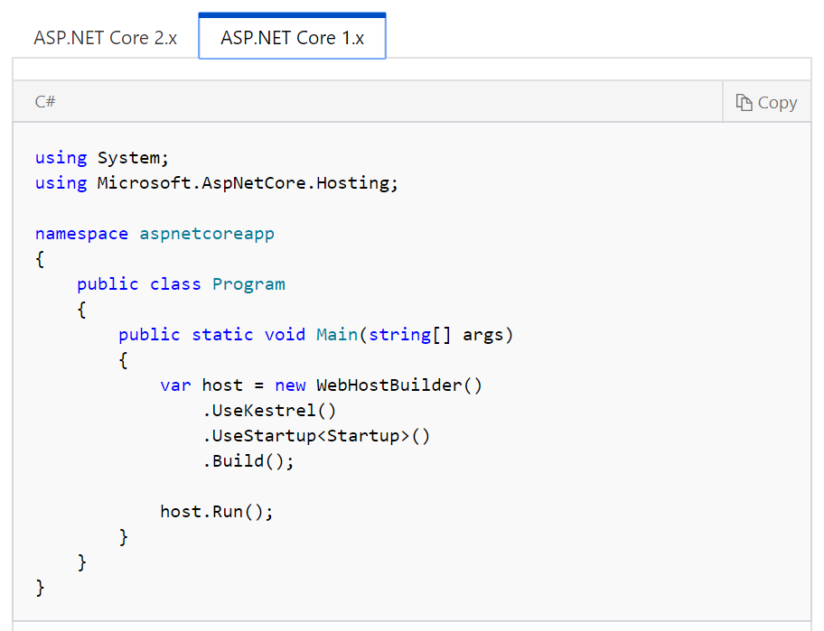

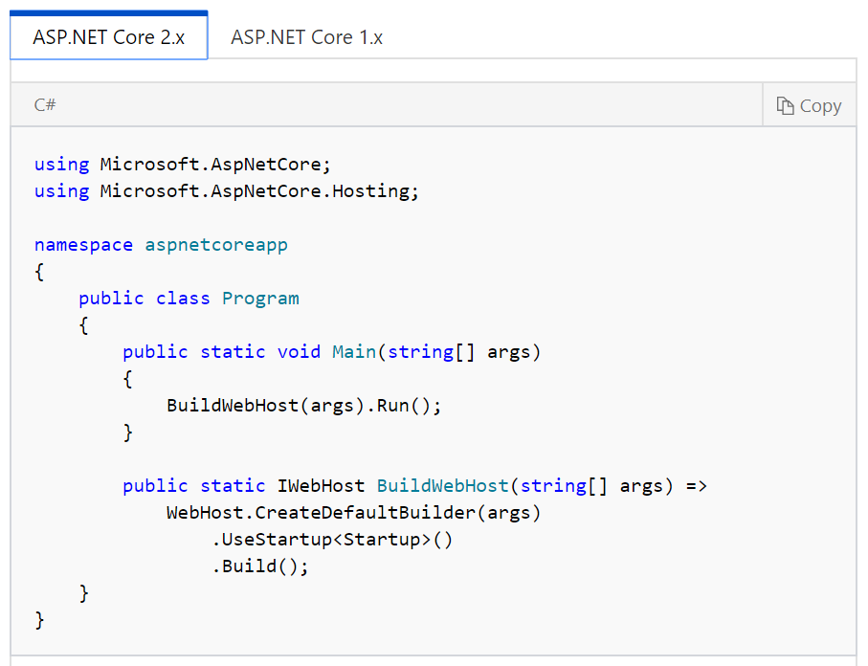

1. Common Gateway Interface (CGI)

* Principle way for a Web server to proceed to the web user’s request to the program of an application and receiving information back to transfer to the client.

History

* In the year 1993 – National Center for Supercomputing Applications (NCSA) have written the specification for calling command line executables
* In the year November 1997 – Work group administered by Ken Coar; Version 1.1 (RFC 3875)

Definition of Terms

Concept and Sample Codes

1. Frameworks
2. Validate_templatename() – Called after the client passes the form from the name of the template
3. Pre_templatename() – called before the name of the template is transmitted to the browser
4. Post_templatename() – called after the name of the template has been transmitted to the browser and after finishing the CGI.

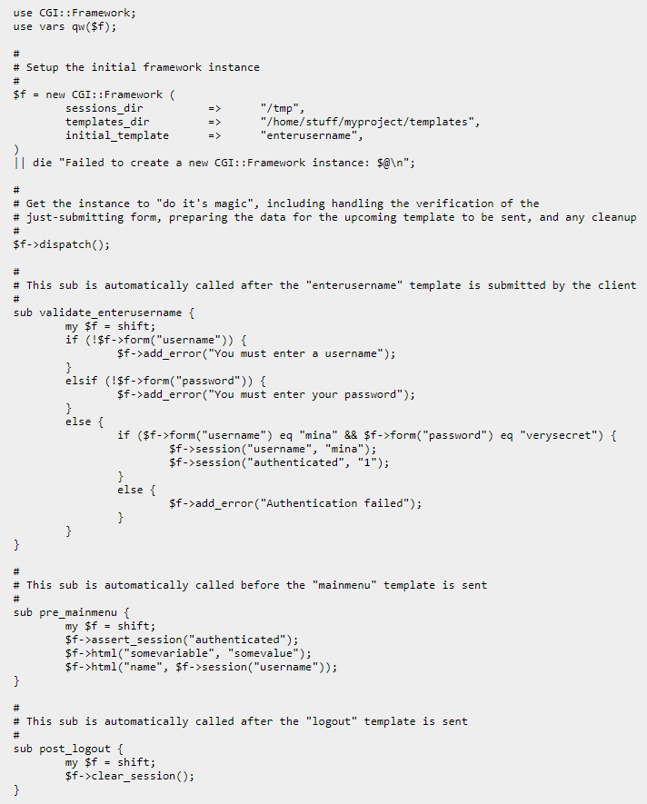

1. Libraries
2. kcgi – Kristaps Dzonsons; open source CGI and FastCGI for C++/C web apps
3. qDecoder – Seungyoung Kim ; helps parsing an encoded request by GET/POST method

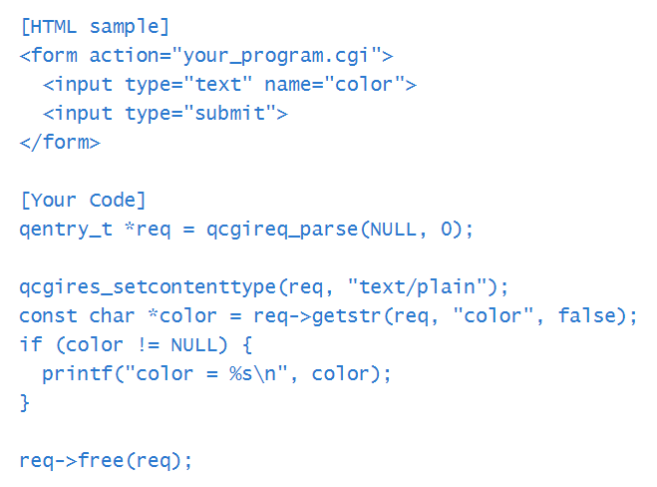

1. cgic – Thomas Boutrell; ANSI C-language library for the making of CGI-based WWW apps
2. Lightweight CGI Library – Martin Schulze; gives an easier utilization of interface to CGI for quick CGI applications written in C and C++ programming language
3. cgi-util – Bill Kendrick Mike Simons; powerful and tiny C library which permits you to make CGI programs for web pages
4. CGI-LIB – Noel Aguilar; Free ASNSI C library and distributed as an open source under MIT license
5. Un-CGI – Steven Grimm; front end for undertaking queries and forms from the Web on UNIX systems
6. Cgihtml – Eric Kim
7. A CGI Library for C – William Charfield; memory and speed optimization on CGI library written in ANSI C
8. Ruby on Rails

* Server-side internet application structure written in Ruby
* Model-view-controller (MVC) framework
* Offering default structures for a database, administrations and web sites
* Empowers and helps utilizing internet prerequisites such:

1. JSON or XML for data transfer
2. HTML, CSS and JavaScript for display and user interfacing

* Emphasizes the utilization of different popular programming designing styles and standards

History

* David Heinemeier Hansson expelled Ruby on Rails from his works on the project management tool Basecamp at the web application

JULY 2004 and FEBRUARY 2005

- He discharges Rails as an open source however did not share devote rights to the mission until the year of 2005 in February.

AUGUST 2006 and OCTOBER 2007

- Ruby on Rails achieved a development when Apple declared that it would convey this structure with Mac OS X v10.5 “Leopard”, which transformed into in October 2007.

MARCH 15, 2009

- They’ve released a new edition of Rails (Rails version 2.3) with principal new patterns in formats, engines, rack and settled model structures.

DECEMBER 23, 2008

- Merb is another web utility system and reported it might work with the Merb task to convey its considerable considerations into Rails 3 completing the unnecessary duplication throughout the two communities and this structure wind up converged with rails.

Rails 3.1: Launched on August 31, 2011, proposing Reversible Database Migrations, Asset Pipeline, Streaming, jQuery as default JavaScript library and recently brought CoffeeScript and Sass into the stack.

Rails 3.2: Launched on January 20, 2012 with a quicker advancement mode and routing engine (also known as Journey engine), Automatic Query Explain and Tagged Logging. Rails 3.2.x is the remaining version that supports Ruby 1.8.7. Rails 3.2.12 supports Ruby 2.0.

Rails 4.0: Launched on June 25, 2013, introducing Russian Doll Caching, Turbolinks, Live Streaming in addition to making Active Resource, Active Record Observer and other components non-compulsory by means of spitting them as gem stones.

Rails 4.1: Launched on April 8, 2014, introducing Spring, Variants, Enums, Mailer previews, and secrets.yml.

Rails 4.2: Introducing Active Job, asynchronous emails, Adequate Record, Web Console, and foreign keys which was launched on December 19, 2014.

Rails 5.0: Launched on June 30, 2016, introducing Action Cable, API mode, and Turbolinks 5.

Rails 5.0.0.1: Launched on August 10, 2016, with extraordinary use of rails CLI over rake and helps Ruby 2.2.2+ variations

Rails 5.1: Launched on April 27, 2017, introducing JavaScript integration changes (control of JavaScript dependencies from NPM via Yarn, non-obligatory compilation of JavaScript - the usage of Webpack, and a rewrite of Rails UJS to utilize vanilla JavaScript in preference of relying on jQuery), gadget assessments using Capybara, encrypted secrets, parameterized mailers, direct & resolved routes, and a unified form_with helper replacing the form_tag/form_for helpers.

Frameworks:

A framework is a software, set of programs, as well as code library written in the vast majority of your application. While utilizing a framework, your assignment is to record the components of the product that influence it to do the particular things you need.

* Describe and model your application's area

1. universe of your product
2. music store
3. a university
4. dating administration
5. an address book
6. Equipment stock

* Specify what can happen in this area

1. The domain model is static; you need to make it dynamic.
2. Addresses can be delivered to an address book.
3. Musical scores can be purchased from tune stores.
4. Users can log in to a courting service.
5. Students can sign up for classes at a university.
6. You need to identify all the possible scenarios or actions that the elements of your domain can participate in.

* Choose and layout the publicly available views of the domain

1. You can start wondering in Web-browser phrases. Once you've decided that your domain has students, and that they can register for classes;
2. You can envision a welcome page, a registration page, and a confirmation page, and so on. Every of these pages, or perspectives, suggests the user how matters stand at a certain point.

Ruby on Rails MVC Framework

The Model View Controller partitions crafted by an application into three independent however firmly helpful subsystems.

1. Model (ActiveRecord )

It proceeds with the association among the items and the database and handles approval, association, exchanges, and so on.

1. View ( ActionView )

It is an introduction of information in a specific organization, activated by a controller’s choice to exhibit the information. They are content-based layout frameworks like JSP, ASP, PHP, and simple to coordinate with AJAX innovation.

1. Controller ( ActionController )

The office inside the application that coordinates movement from one viewpoint, questioning the models for particular information, and then again, arranging that information (seeking, arrangement, informing it) into a shape that fits the requirements of a given view.

Migrations

Rails Migration enables you to utilize Ruby to characterize changes to your databse diagram, making it conceivable to utilize an adaption control framework to keep things synchronized with the real code.

Numerous utilizations of Migrations:

* Group of developers − If an individual rolls out a schema change, the other designers just need to update, and run "rake migrate".
* Production servers − Run "rake migrate" when you reveal another discharge to convey the database up and coming too.
* Multiple machines − if you create on both a work area and a workstation, or in excess of one area, movements can enable you to keep them all synchronized.

What Can Rails Migration Do?

* create_table(name, options)
* drop_table(name)
* rename_table(old_name, new_name)
* add_column(table_name, column_name, type, options)
* rename_column(table_name, column_name, new_column_name)
* change_column(table_name, column_name, type, options)
* remove_column(table_name, column_name)
* add_index(table_name, column_name, index_type)
* remove_index(table_name, column_name)

Migrations support all the basic data types − The following is the list of data types that migration supports −

* string − small data types like titles
* text − longer bits of printed information like depiction.
* integer − whole digits
* float – decimals
* datetime and timestamp − store the date and time into a section.
* date and time − store either the date or time only
* binary − putting away information like pictures, sounds or films
* Boolean − accompanying is the rundown of legitimate section choices.

Substantial segment alternatives are − The following is the rundown of legitimate sections options.

* limit ( :limit => “50” )
* default (:default => “blah” )
* null (:null => false implies NOT NULL)

Other Server-Side Web Scripting Technologies

1. ASP.NET: This Microsoft framework is the most popular enterprise-degree framework—it helps multiple programming languages concurrently for one mission. So, the identical application can be constructed with both C# and C++, through CLI (common language interface). It is the most latest iteration, ASP.NET 5, is now open to non-Windows structures for the primary time.
2. Code Behind Model: Microsoft recommends dealing with dynamic program code by using the code-behind model, which places this code in a separate file or in a specially designated script tag. Code-behind files typically have names like "MyPage.aspx.cs" or "MyPage.aspx.vb" while the page file is MyPage.aspx (same filename as the page file (ASPX), but with the final extension denoting the page language).
3. Django: This Python framework changed to fulfill the needs of development in a fast-paced surroundings and have web sites such as Pinterest, Nasa, Pitchfork

* Designed to help developers take applications from concept to completion as quickly as possible
* Takes security seriously and helps developers avoid many common security mistakes
* Some of the busiest sites on the Web leverage Django’s ability to quickly and flexibility scale

1. Express.js & Koa: These JavaScript-powered middleware frameworks work on top of the Node.js improvement environment and control the float of records on the back end of a site.

* In June 2014, rights to manage the project were acquired by StrongLoop.
* StrongLoop was acquired by IBM in September 2015
* In January 2016, IBM announced that it would place Express.js under the stewardship of the Node.js Foundation incubator.